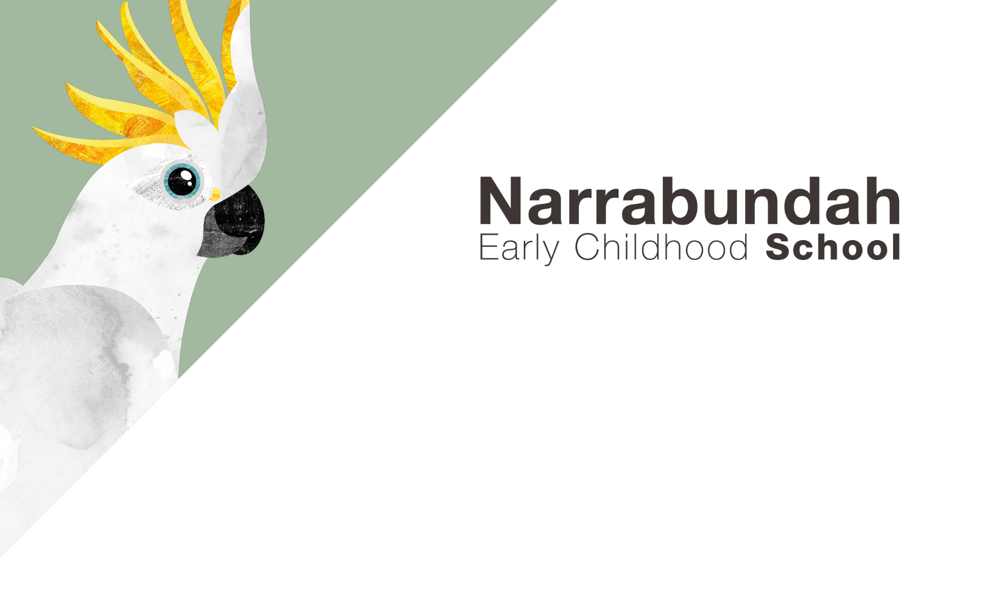

SCHOOL UNIFORM ORDER FORM

How to order school uniform:
- Fill out the form below and calculate total cost
- Make payment via the school website and provide the payment details on the form
- Return form to Front Office
- Orders will be available for pickup from the Front Office within two days of payment being received.

Student Name: ________________________________________________

UNIFORM ITEM | PRICE |  | SIZE  (PLEASE CIRCLE) | QUANTITY | COST
POLO SHIRT SHORT SLEEVE | $32 |  | 2 4 6 8 10
POLO SHIRT LONG SLEEVE | $38 |  | 2 4 6 8 10
HOODIE JUMPER | $43 |  | 4 6 8 10
HAT | $14 |  | One size
BEANIE | $9 |  | One size
SEW ON LOGO PATCH | $2.50 |  | 9cm x 7cm
 |  |  | TOTAL

Payment can be made via the school website: www.necs.act.edu.au
Click on the Payment tab click on the QuickWeb link complete the form (student key is the first 5 letters of your child’s surname and the first letter of their given name) under Payment Options select Other Fee Code is ‘Uniform’, Payment Amount is the total of your order above
Payment Date: ________________________________________________
Receipt Number: ______________________________________________

